MASS EMAILING USING AWS LAMBDA
BY: A.KEERTHANA (AWS & DEVEOPS)
JUNE 16th batch
Mass emailing using AWS Lambda refers to the process of using AWS Lambda, a serverless computing service, to send emails to a large number of recipients (mass emailing) automatically, without the need for managing traditional email servers.

Services used for mass emailing:
IAM Roles
SES ( simple email service)
Lambda
S3 for upload file (optional)

Steps to create Mass emailing using AWS lambda:
Step 1 : create IAM role
Roles >>> lambda
Permission >>> SES full access, s3 full access (optional) if upload file
Rolename >>>> mass-mailing
Then create role
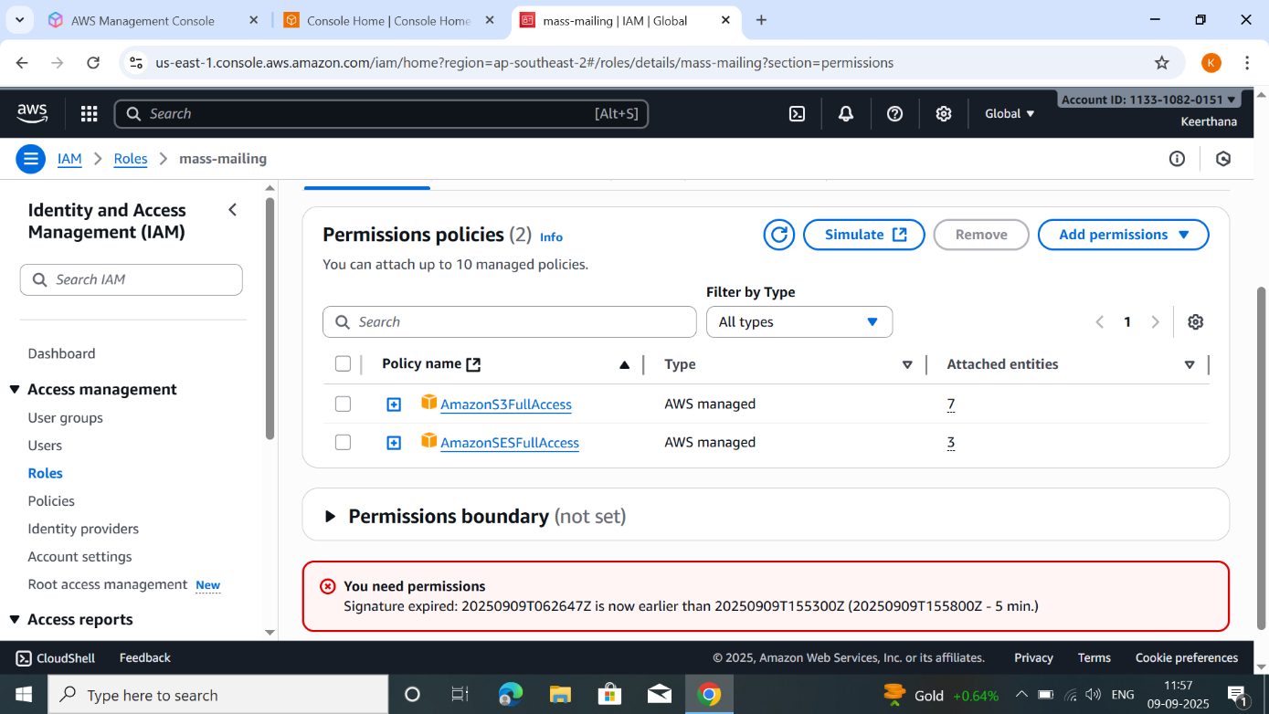

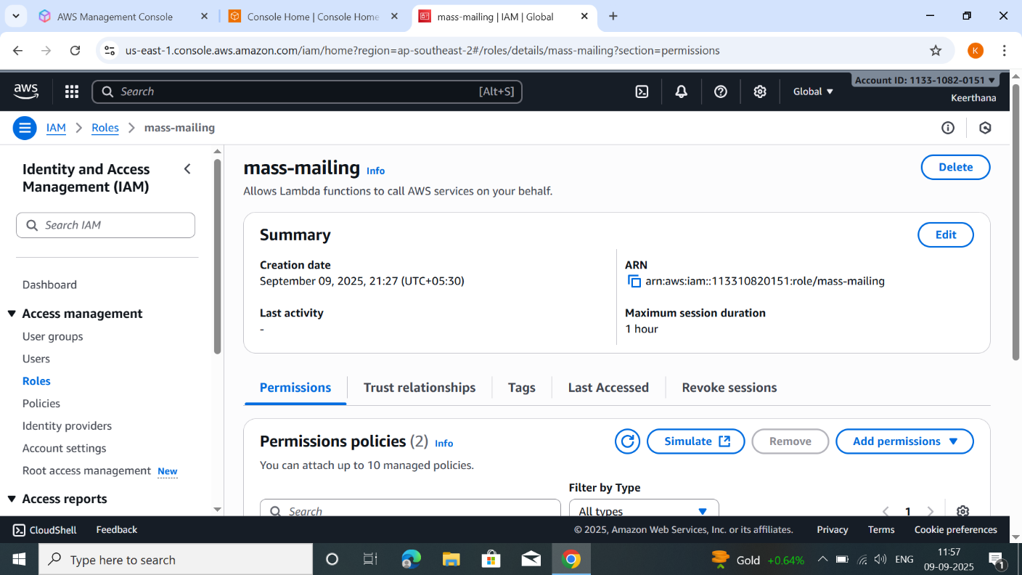

Step 2 : create SES
Configuration >>> identity >>> create identity >>> email address >>> now created
Same process create another email address.
After create email address go to check…. Received email from AWS then click the link to verify.
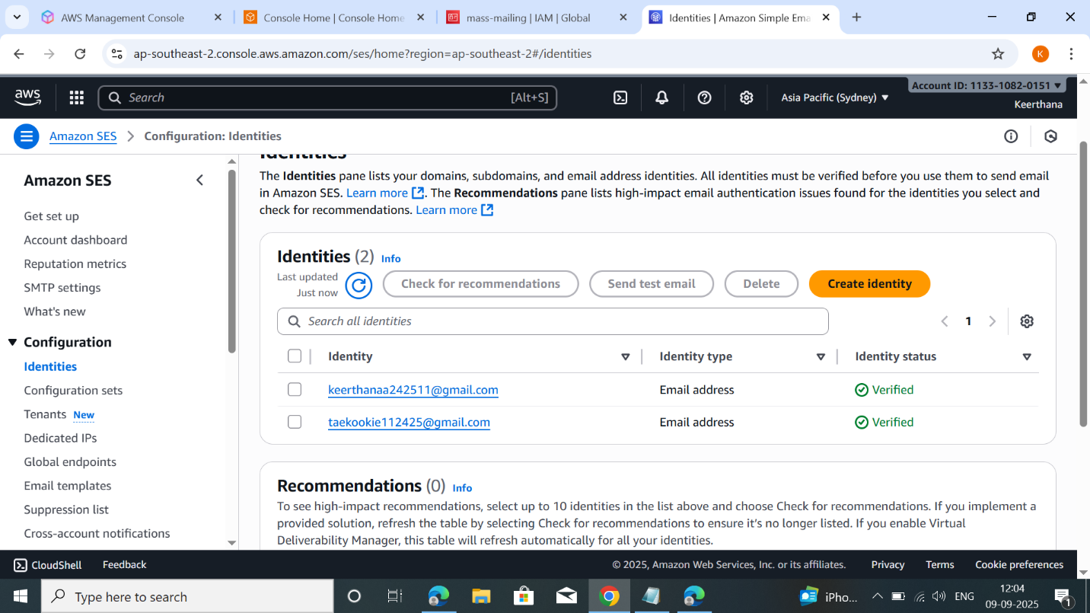
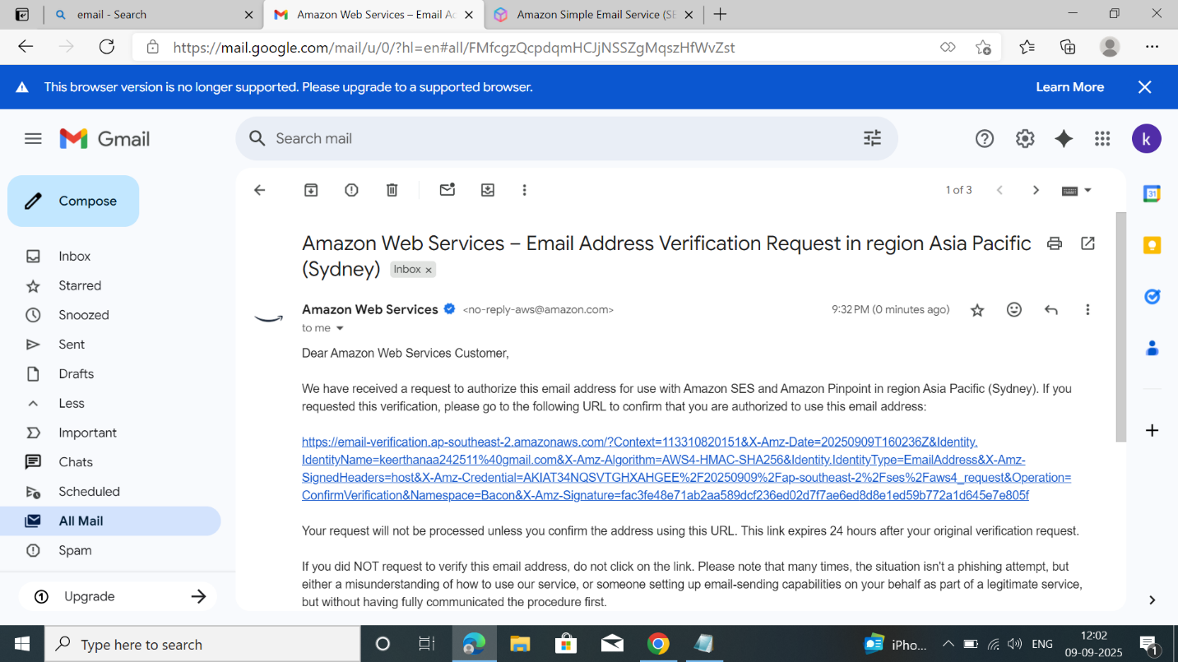
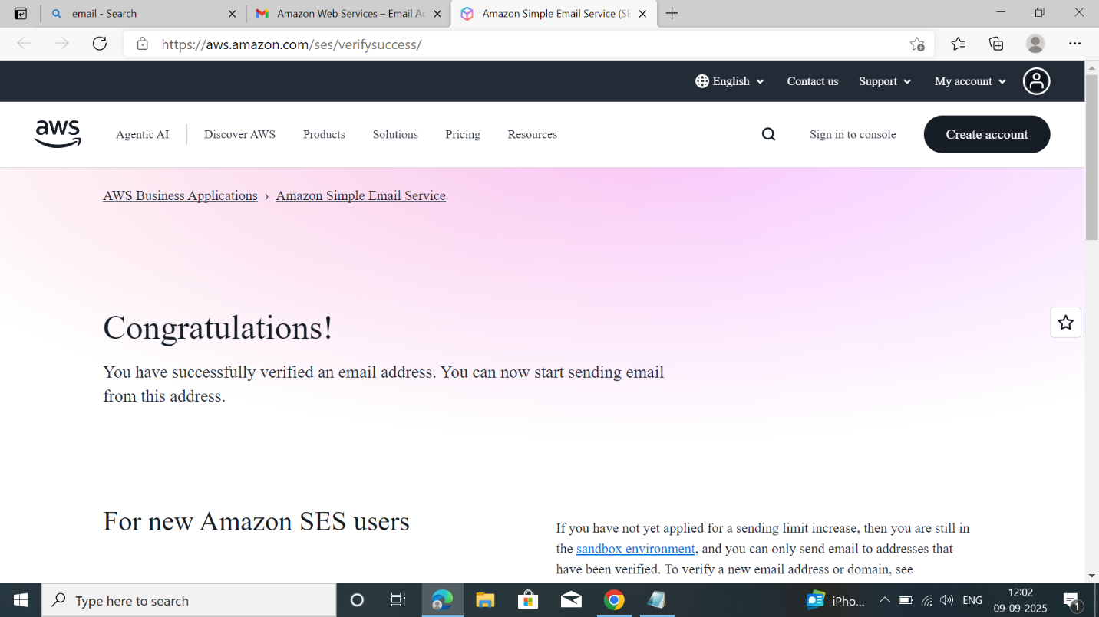
Step 3: create Lambda
Create the lambda function >>> lambdasydney
Runtime >>> python 3.9
If upload file add trigger (s3)
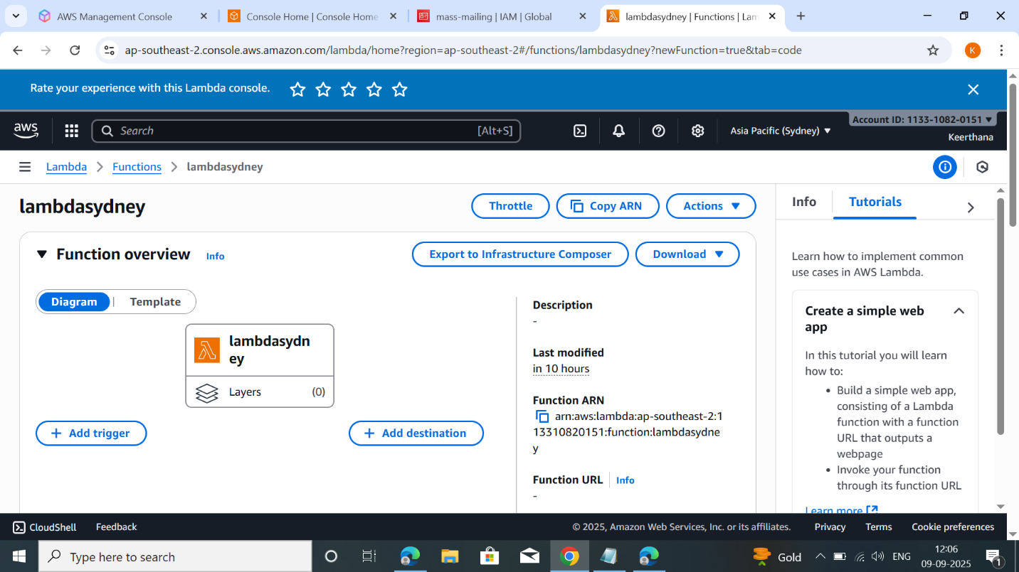
Apply the python code in code source
Code:
import boto3
from botocore.exceptions import ClientError

ses = boto3.client('ses', region_name='ca-central-1')

def lambda_handler(event, context):
sender = 'keerthanaa242511@gmail.com' # Verified sender
recipient = 'taekookie112425@gmail.com' # Verified recipient

subject = 'Test Email'
body_text = 'Hello!'

try:
response = ses.send_email(
Source=sender,
Destination={'ToAddresses': [recipient]},
Message={
'Subject': {'Data': subject},
'Body': {'Text': {'Data': body_text}}
}
)
print("Email sent! Message ID:", response['MessageId'])
return {"status": "success", "message_id": response['MessageId']}

except ClientError as e:
print("Error sending email:", e.response['Error']['Message'])
return {"status": "error", "error_message": e.response['Error']['Message']

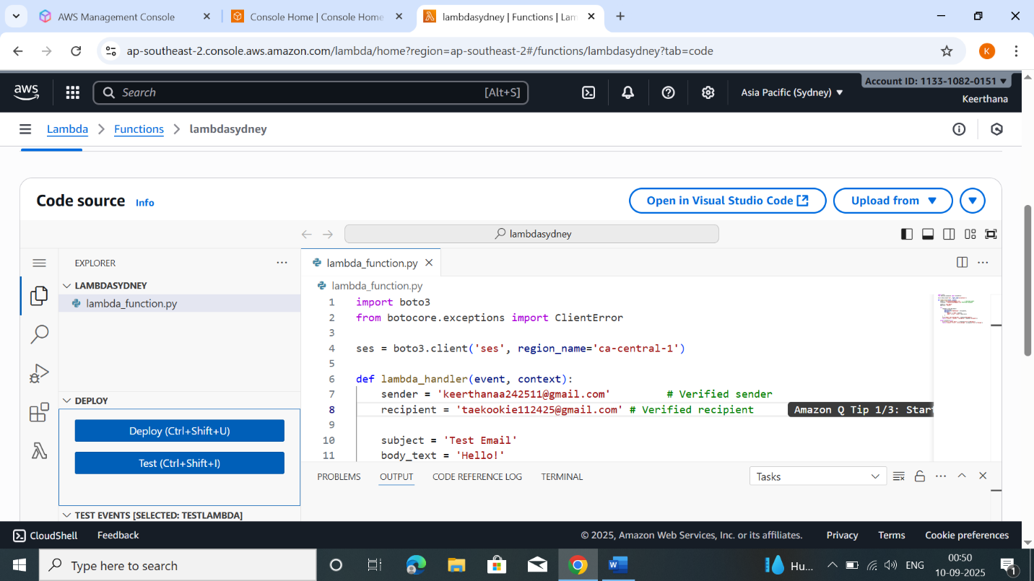
deploy and test code.

Now check the mail…

Output:

